A new cloud service for managing a smart hospital

**Introduction**

1-how smart hospital is very important for patients and countries

2-the time and the cost of smart hospital compared with the traditional hospital management

3-how our project will be useful for reducing the time and the cost. In addition, how it will be save for patients and doctors

4-

**Literature review**

The papers with the same our idea

**Our idea**

Our smart hospital has three floors: ground floor, first floor, and second floor. Each floor has some functionalities. In the ground floor: there is a smart reception system that is based on NLP technology to save the information of patients.

**NLP system**

**----------------------**

In the first floor, there are three smart systems: Mask detection system, counter system, and desktop application.

Mask detection system

بالتفصيل نتكلم عن الفكره وخطواتها

counter system

بالتفصيل نتكلم عن الفكره وخطواتها

desktop application.

بالتفصيل نتكلم عن الفكره وخطواتها

In the second floor, we develop a new emoji detection system for reassuring the patients when they appear anxious

**emoji detection system**

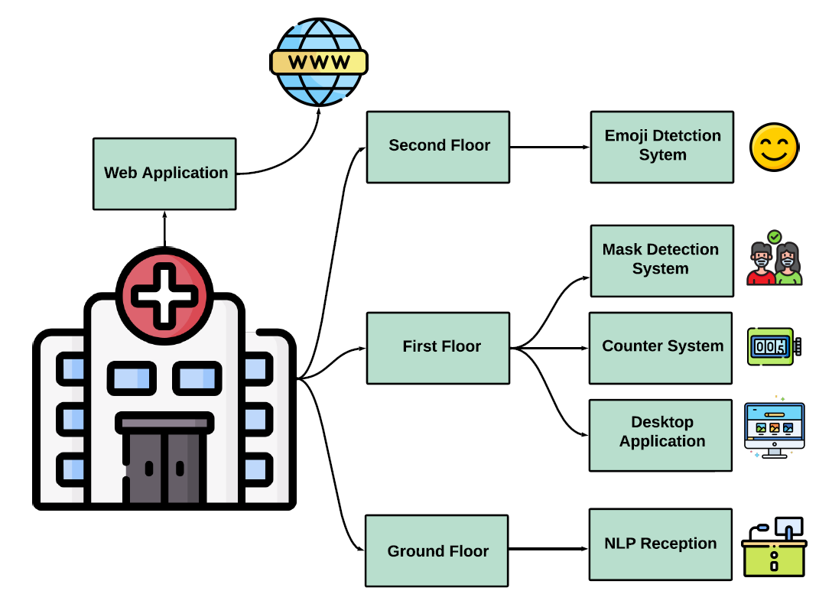

**Results and discussion**